**The Implications of Brexit in oxford**

**Date : 26-06-2018**

**From : Head Of Financial Services**

**To : Finance Scrutiny Panel**

**Background**

The Head of Financial Services has provided a number of updates to the Finance Scrutiny Panel following the vote for Brexit on 23rd June 2016 and the triggering of article 50 on 29th March 2017 signalling the commencement of Britain’s exit from the EU. The last report in August 2017 provided an update on the issues affecting the economy generally and any potential issues for Oxford City and concluded that nothing significant was emerging and in reality ‘it was too early to tell.’ This paper revisits the subject by updating previous information and overlaying latest Brexit information.

**Executive Summary**

This update gives an overview of the latest national position on Brexit and the implications both for the City of Oxford and also Oxford City Council.

Over the last few months the UK Government has focused on the Brexit divorce deal. Whilst the main issues of the Irish Border, how much the UK will owe or what happens to EU citizens living in the UK have still all to be agreed there sufficient common ground to allow negotiations to continue. Clearly the ‘devil will still be in the detail’. In addition there is confirmation that there will be a transitional period between 29/3/2019 and December 2020 during which the UK will be able to strike its own trade deals but they won’t come into force until January 2021.

Recent demonstrations in the UK have called for a public vote on the final negotiations and major businesses such as Airbus, BMW and Unipart have raised their concerns about the potential implications for them in the event of no deal.

In other developments :

* The LGA have published what they see are their key priorities including :
  + Autonomy of local government
  + Developing a new legal base for local government
  + Securing investment that is currently sourced from the EU
  + Community cohesion
  + Addressing place-based impacts
* The Council have provided information to the LGA highlighting the implications for Oxford of exiting the EU on the labour market and the impact on particular sectors. The paper concludes that Brexit brings specific risks to our major employers, and the city’s key sectors as with many other areas of the UK. Depending on the outcome of negotiations with the EU, the consequences could be damaging for growth and productivity, science and technology, and public services.

The impact on the City Council is currently limited in terms of recruitment issues, key income streams and property funds although like most authorities the Council is suffering from depressed returns from investment over the last few years which are now showing signs of increase to pre Brexit levels. Whilst PWLB borrowing rates are still relatively low, should these rates increase post Brexit then the net returns from loans to the Housing Company will be lower, adversely impacting the Council’s Medium Term Financial Plan.

Given the total withdrawal of Revenue Support Grant from local authorities by the Government from 1/4/2019 the reliance on business rates income is critical for local authorities. Uncertainty around the proposed changes in the Business Rates retention methodology under the Government’s ‘fairer funding’ system is already a key risk for the authority. Recent statements from major employers and significant Business Rates contibutors such as BMW and Unipart, expressing concern over the lack of clarity over future trade arrangements, add to the uncertainty.

In summary whilst there is still a lot to be negotiated, there are still a number of issues and concerns for the country, local Government, Oxfordshire and Oxford City Council although at this stage these are still too early to quantify. However, the Government’s award of the £215 million Oxfordshire Housing & Growth Deal earlier this year, and its commitment to the proposed Oxford-Cambridge Growth Corridor potentially offers significant mitigation going forwards. With two leading universities and many internationally significant knowledge intensive industries based in and around Oxford, the Government has stated its ambition to create a rival to ‘Silicon Valley’ here and across the arc to Cambridge.

**The story so Far**

Following the triggering of Article 50 the Government officially opened negotiations with the EU on 19th June 2017.

In December 2017 the UK and EU provisionally agreed on the main three "divorce" issues. Although these issues have not been completely agreed both parties agreed that sufficient progress had been made to enable negotiations to move on. In summary the position agreed was :

## How much the UK owes the EU - The deal in December did not contain an exact figure, though at the time, UK officials estimated a [potential bill of £35–39 billion](https://www.independent.co.uk/news/uk/politics/brexit-divorce-bill-financial-settlement-39-billion-theresa-may-juncker-agreement-northern-ireland-a8099076.html) (bn). The UK’s Office for Budget Responsibility (OBR) set out detailed estimates of what the UK would pay in its [Economic and Fiscal Outlook report](http://cdn.obr.uk/EFO-MaRch_2018.pdf), published alongside the Chancellor’s Spring Statement. That set out a total bill of €41.4bn (£37.1bn), extending out to 2064 as pension liabilities fall due.

* **What happens to EU citizens living in the UK** - Around 3.6 million EU Nationals currently live in the UK including 600,000 children. It has been confirmed that all EU nationals currently here will get settled status and stay here indefinitely. EU Nationals arriving after March 2019 would be given temporary status allowing them to stay beyond the transition phase. They will then be given 5 years to apply for indefinite leave to remain.
* **What happens to the Northern Ireland border** – Although the UK is committed to stop participating in the Customs Union and Single market by March 2019 Dublin wish to remain in both. If British negotiators fail to come up with a means of avoiding a hard border between Northern Ireland and the Republic, then the UK "will maintain full alignment with those rules of the Internal Market and the Customs Union."

**Transition Period**

In recent developments agreement has been reached on the Transition Period a period of time after 29 March, 2019, to 31 December, 2020, to get everything in place and allow businesses and others to prepare for the moment when the new post-Brexit rules between the UK and the EU begin. It also allows more time for the details of the new relationship to be fully hammered out. Free movement will continue during the transition period, as the EU wanted. The UK will be able to strike its own trade deals - although they won't be able to come into force until 1 January 2021.

**Impacts of Exiting Customs Union and Single Market**

**The Single Market**

The Single Market provides direct access to around 450 million customers with the lowest possible barriers. Members can be in the EU's Single Market, but not the EU, this is what Norway, Iceland and Liechtenstein do. The European Union's single market is perhaps the most ambitious type of trade co-operation. That's because as well as eliminating tariffs, quotas or taxes on trade, it also includes the free movement of goods, services, capital and people. Also, a single market strives to remove so-called "non-tariff barriers" - different rules on packaging, safety and standards and many others are abolished and the same rules and regulations apply across the area.

Leaving the Single Market would remove the UK from EU jurisdiction and allow it to sign trade deals without interference with other countries.

**Customs Union**

In a Customs Union the countries club together and agree to apply the same tariffs to goods from outside the union. Once goods have cleared customs in one country, they can be shipped to others in the union without further tariffs being imposed. Turkey is part of a customs union with the EU but not in the single market. The deal does not cover food or agriculture, services or government procurement.

If the UK left the Customs Union but stayed in the Single market, our exporters would have to contend with what are called 'rules of origin'. These rules are designed to demonstrate that goods that legally originated in the UK - and did not contain more than the maximum permitted level of parts and components from elsewhere - qualify for duty-free entry into the EU.

Membership of the customs union would ensure goods were not subject to import tariffs or, probably more importantly, to checks that they met EU standards.

**Exiting Single Market and Customs Unions Implications for UK Business**

In recent announcements:

* **CBI** -Sections of UK industry face extinction unless the UK stays in the EU customs union, the CBI president has said.
* **Airbus -** Airbus employs about 14,000 people at 25 different sites in the UK. In its Brexit "risk assessment, Airbus said if the UK left the EU next year without a deal - meaning it left both the single market and customs union immediately and without any agreed transition - it would "lead to severe disruption and interruption of UK production". "This scenario would force Airbus to reconsider its investments in the UK, and its long-term footprint in the country," it added.
* **BMW** has said it will be forced to close its production sites in the UK, putting 8,000 jobs at risk, if components for Mini and Rolls-Royce cars are caught up in customs delays after [Brexit](https://www.theguardian.com/politics/eu-referendum). They also added their backing to comments made by Airbus that jobs could disappear into Europe if the UK left the EU without a deal.
* **Letter to PM –** The Uk’s five main business lobbies, the CBI, Institute of Directors, British Chamber of Commerce and the Federation of Small Businesses, have written to the PM urging her to make progress on Brexit negotiations or risk losing jobs.
* **Britain’s midsized companies-** the majority want the country to leave the EU single market and the customs union, according to a new poll. The recent survey, carried out by YouGov, found that less than half would opt for the relationship Norway or Switzerland has with the bloc, which includes accepting EU regulations in return for single market access. The view contrasts with that of big business, which has called for the “widest possible rights of market access.

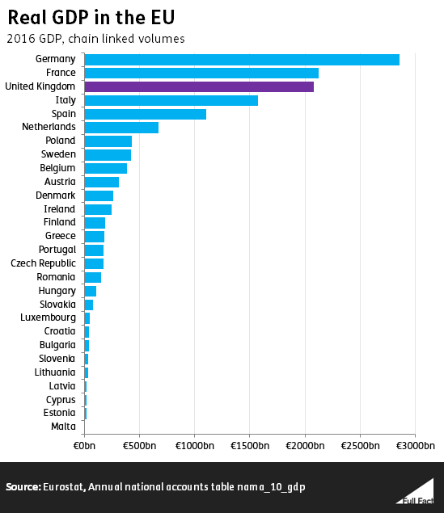

**Local Government Association Response**

Since the decision to leave the EU in 2017 the LGA have published a number of papers on the response of local government. In a recent paper following widespread consultation with councils, they set out local government's five priority recommendations for the Brexit negotiations. These headline priorities are:

* **Autonomy of local government**  
  Responsibilities repatriated from the EU should not be centralised in Whitehall. We need devolution settlements to ensure responsibility for those powers are transferred to local authorities.
* **Developing a new legal base for local government**  
  There are many EU laws that affect the day job of local councils and the real world impact must be taken into account in the future review of UK laws of EU origin. This must lead to new legislative freedoms and flexibilities for councils so that communities, businesses and consumers can benefit.
* **Securing investment that is currently sourced from the EU**  
  The Government needs to begin developing a locally-driven, fully-funded growth policy to deliver its ambitions post-Brexit. This must be designed and delivered by local areas as an integrated replacement for EU funding and existing national schemes to support infrastructure, enterprise, and social cohesion.
* **Community cohesion**  
  Councils play the leading role in bringing communities together and will be important in tackling challenges such as the retention of skilled workers. For example, the adult social care workforce has a unique set of skills, but struggles with recruitment and retention. With 7 per cent of existing adult social care staff from other EU nations, securing a sustainable adult social care workforce and excellent care skills must be a priority for the Government. We are calling for urgent guarantees from Government to reform Whitehall's national approach to commissioning employment and skills funding, worth £10.5 billion a year. It is currently fragmented, costly, and fails to address the challenges faced by residents and employers.
* **Addressing place-based impacts**  
  In partnership with the LGA, government departments must begin to address the real and varied impacts and opportunities of Brexit at the local level, in both urban and rural areas. We are consulting widely and building our evidence base to support the exit negotiations.

In 2018 the Local Government Association called on local authorities to provide information in order to assist them in the second phase of Brexit negotiations and create a pro-active, forward facing view of local government after the UK's exit from the European Union. A copy of the Councils full reply can be found on the website at

<https://www.google.co.uk/search?q=LGA+Call+for+Evidence%3A+The+Impact+of+EU+Exit+on+Places&gws_rd=ssl>

A summary of the main findings are as follows :

**Are there likely to be any significant changes to the labour market in your local area as a consequence of exiting the EU?**

**Table 1: Non UK European workers in Employment**

The following shows the number of non UK Europeans in employment in Oxford which represents around 12% of the total population aged between 16 and 64 in employment. Around 11% are from EU countries.



There is already evidence of employees in a range of business feeling uncertainty about their continued status in the UK, or returning to their country of origin. The reversal of EU citizen status will impact on the attractiveness of all UK locations to international and EU labour. In Oxford specifically, it is expected that impact will be felt widely, across the highest skilled sectors, middle income professions and service professions; areas where there are known labour shortages such as ICT, science, technology research and engineering disciplines, the healthcare and hospitality sectors for example.

**Are there likely to be any significant impacts on particular economic sectors in your local area as a consequence of exiting the EU ?**

* **Higher education** - Access to research grants and partnerships will be reduced, as will access to EU researchers and students, due to the restriction of free movement of labour.
* **Bio Tech -** Many of the companies operating in the sector are targeting export markets and three of the main concerns for the biotech sector that arise are:
  + Access to talent
  + reduction in funding and investment in the biotechnology sector
  + The country's role in managing regulations affecting the sector
* **Research, science and technology** -Oxford has numerous world-leading science and ‘Big Science’ assets that face an uncertain future because of;
  + - their direct links to EU wide infrastructure
    - reliance on EU talent
    - reliance on EU funds
    - A need for international collaborative efforts to achieve genuine impact
* **Visitor Economy** - Oxford’s tourism sector accounts for almost 12.8% of local employment, supported by 6.6M annual trips and spend of £625m per annum. Overseas visitor spending is more than double that of domestic visitors. Given this importance, there is significant interest in what Brexit may mean for Tourism longer term. As it stands, there is uncertainty, and there are several anecdotal points that the sector have expressed;
  + Domestic Tourism – As it is now more expensive for UK residents to go overseas it makes domestic holidays more appealing.
  + Inbound Tourism – Due to the strength of the pound (or lack of it) against the euro and dollar we are now ‘cheaper’ to visit in destination terms which should see an upturn in the inbound market.
* **Local businesses** -Below are some of groups of responses highlighted in the Bank of England Agent’s conversations with local companies in the Oxford and Midlands area in the period to November 2016;
  + - Business as usual for now
    - Some fear they face cliff edge in terms of market access and supplier arrangements
    - The regulatory piece is of concern
    - Concerns over supply chain complexity with individual negotiations for different markets
    - Uncertainty regarding sourcing migrant labour
    - Talk of automation due to potential labour shortages
    - More indigenous hiring and training where possible
    - Talk about relocation to access markets
    - Businesses talk of needing a plan A and plan B due to the uncertainty
* **BMW Mini** Three plants across the UK have a part to play in MINI production - Plant Swindon where body panels and some assemblies are made, Plant Hams Hall which produces petrol engines and Plant Oxford, the heart of MINI, where all the parts are brought together and where the finished car rolls off the production line. There are 4,500 associates currently employed at Plant Oxford. Plant Swindon and Hams Hall plant together have around 1,600 employees. Between 2012 and 2015 BMW Group invested a further £750 million in its Oxford, Swindon and Hams Hall plants taking investment in UK production to £1.75 billion since 2000. There are approximately 4,000 different parts supplied to Plant Oxford for the production of the MINI.

BMW have gone on record in the press. Stating, "BMW Group is committed to the UK, its fourth biggest market and home to two of its brands, and respects the British electorate’s decision to leave the EU. Given the current political uncertainty regarding next steps, all we can say regarding our own activities in Britain is that we continue to operate ‘business as usual. Until we receive answers to the many open questions regarding the UK’s future trade relations with the EU and other countries, we cannot speculate about any possible impact Britain’s decision to leave the EU may eventually have on our UK operations."

* **Unipart Group** is a multinational logistics, supply chain, manufacturing and consultancy with almost 1,000 employees based at their Oxford Headquarters. Unipart have 6,700 employees worldwide, customers and partners in all EU member countries, and operations in the Netherlands and Spain. Unipart have articulated three key concerns related to the uncertainty resulting from the EU referendum:
  + Complexity of operations –
  + Freedom of movement for existing staff –.
  + Uncertainty for capital investments and employees – Unipart have been aware of delays in significant capital investments in their

**Other Relevant Data for Oxford**

### EU Citizens, Oxford Residents

Empirical research has shown that opportunities for employment and higher wages compared to their origin countries could have been strong pull factors for EU migrants to the UK since the accession of the A8 (“new”) EU countries in 2004. Weekly workplace wages in Oxford have been consistently higher than the national average since 2005.

Source: Annual Survey of Hours and Earnings (ASHE), average gross weekly residence based earnings. CPI inflation adjusted (2012=100). Note: ASHE statistics are based on a sample survey, so the statistical significance of the results should be treated with caution.

Between the last two UK Censuses, the number of residents who were born in the EU grew by over 7,000, comprising 8.3% of Oxford’s usually resident population as of the 2011 Census.

Oxford residents with EU passports represent a broad range of skills, training, and educational backgrounds. Taking a closer look into those who hold EU passports (Table A), over half those from the “old” EU countries are more likely to have a Level 4 qualification or above, meaning a bachelor’s degrees and above. In contrast, the percentage of those from the “new” EU countries is lower at 39%; however, around a third from those countries had previous experience through apprenticeships and / or other qualifications.

**Table A: Passports held by qualifications, Oxford usual residents**

|  |  |  |  |  |  |  |  |
| --- | --- | --- | --- | --- | --- | --- | --- |
| **Passports Held** | **All categories** | **No qualifications** | **Level 1 qualifications** | **Level 2 qualifications** | **Level 3 qualifications** | **Level 4 qualifications and above** | **Apprenticeships and other qualifications** |
| All categories: Passports held | 126,725 | 14% | 8% | 9% | 18% | 43% | 9% |
| Europe: Total | 102,971 | 11% | 8% | 9% | 20% | 44% | 8% |
| **Europe: United Kingdom** | ***88,804*** | ***12%*** | ***9%*** | ***10%*** | ***22%*** | ***43%*** | ***5%*** |
| Europe: Ireland | 1,764 | 18% | 5% | 7% | 13% | 48% | 9% |
| Europe: Other Europe: Total | 12,403 | 5% | 4% | 5% | 9% | 51% | 25% |
| **Europe: Other Europe: EU countries: Total** | ***11,274*** | ***6%*** | ***4%*** | ***5%*** | ***9%*** | ***51%*** | ***25%*** |
| Europe: Other Europe: EU countries: Member countries in March 2001 | 7,127 | 6% | 3% | 4% | 8% | 58% | 21% |
| Europe: Other Europe: EU countries: Accession countries April 2001 to March 2011 | 4,147 | 6% | 5% | 7% | 10% | 39% | 33% |

Source: UK Census 2011

The two universities in Oxford have been a draw for EU migrants, especially those with higher-skill levels, as shown through the number of EU citizens in education or in employment at the universities. In 2016/17, around 42,455 students (graduate and postgraduate) attended the city’s two Universities. Higher education in Oxford accounts for approximately 27,000 jobs, or 22.3% of total employee jobs, and makes up the largest percentage of employees by sector, followed by those employed in hospital activites. Currently 18% of Oxford’s staff and 16% of its students are from elsewhere in the European Union. In 2015/16, it received £74m (14% of its research funding) from the EU.

Access to research grants and partnerships face the risk of being reduced by the impacts of Brexit, as will access to EU researchers and students, due to the possible restriction of free movement of labour.

**Table B Top 10 industries by number of employees, Oxford 2016**

|  |  |  |
| --- | --- | --- |
| **Industry** | **Count** | **Industry percentage** |
| Higher education | 27,000 | 22.3% |
| Hospital activities | 13,000 | 10.7% |
| Construction of residential and non-residential buildings | 5,000 | 4.1% |
| Secondary education | 4,000 | 3.3% |
| Restaurants and mobile food service activities | 3,500 | 2.9% |
| Publishing of books, periodicals and other publishing activities | 3,500 | 2.9% |
| Manufacture of motor vehicles | 3,000 | 2.5% |
| Retail sale in non-specialised stores | 3,000 | 2.5% |
| Activities of head offices | 3,000 | 2.5% |
| Primary education | 3,000 | 2.5% |

Source: Business Register and Employment Survey 2016

.

### Housing Market

Since the referendum vote in 2016, the number of sales transactions for housed in Oxford has dipped. Although the annual trend data follows the same pattern of peaking in the summer and declining until the next summer, the number of sales is proportionately lower than the levels between 2013 and 2015.

On the other hand, the average prices of houses sold in Oxford has remained relatively stable since the vote, and has actually increased since the referendum. The higher prices of houses sold indicates the housing market in Oxford has remained more resilient at the top end.

Source: Land Registry 2018

**Data Relevant To Oxford City Council**

**Investments and Borrowing**

**Credit Rating of UK**

* The UK’s Sovereign credit rating continues to stand at AA with negative outlook with all three of the main ratings agencies; Standard & Poor, Fitch and Moody’s. This reflects their view of the economic uncertainty following the Brexit vote and the expectation of slower UK economic growth over the medium term.
* The UK continues to be deemed less credit worthy than the US, Australia, Canada, Denmark, Germany, Holland, Singapore, Sweden and Switzerland.
* The shareholders of the European Investment Bank (EIB) are the 28 Member States of the European Union and the UK has a 16.11% shareholding in the EIB. This position has not changed since the Brexit referendum or the subsequent triggering of Article 50

**Interest rates**

In November 207, the Bank of England's Monetary Policy Committee voted to increase base rate back to 0.50% following its previous decision to cut base rate to 0.25% in August 2016.

There was further speculation of a subsequent base rate rise in May 2018 but this did not materialise following a 7-2 vote in favour of holding base rate at 0.5%

Link Asset Services, the Council’s Treasury advisors have revised their interest rate forecasts and do not expect a further rise until November 2018. This is shown in the table below. However, Link has also stated that much of their forecast will depend on how the Brexit negotiations stand and what levels of uncertainty will remain in respect of the UK’s future engagement with the EU.

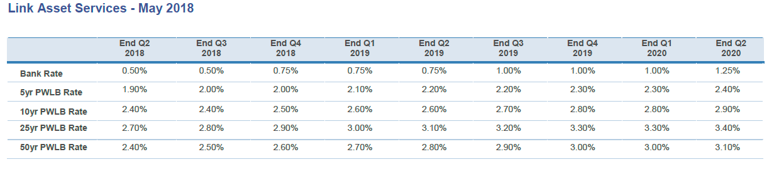

PWLB borrowing rates continue to fluctuate but remain at an all-time low. The chart below illustrates the movement in rates from November 2017 to May 2018.

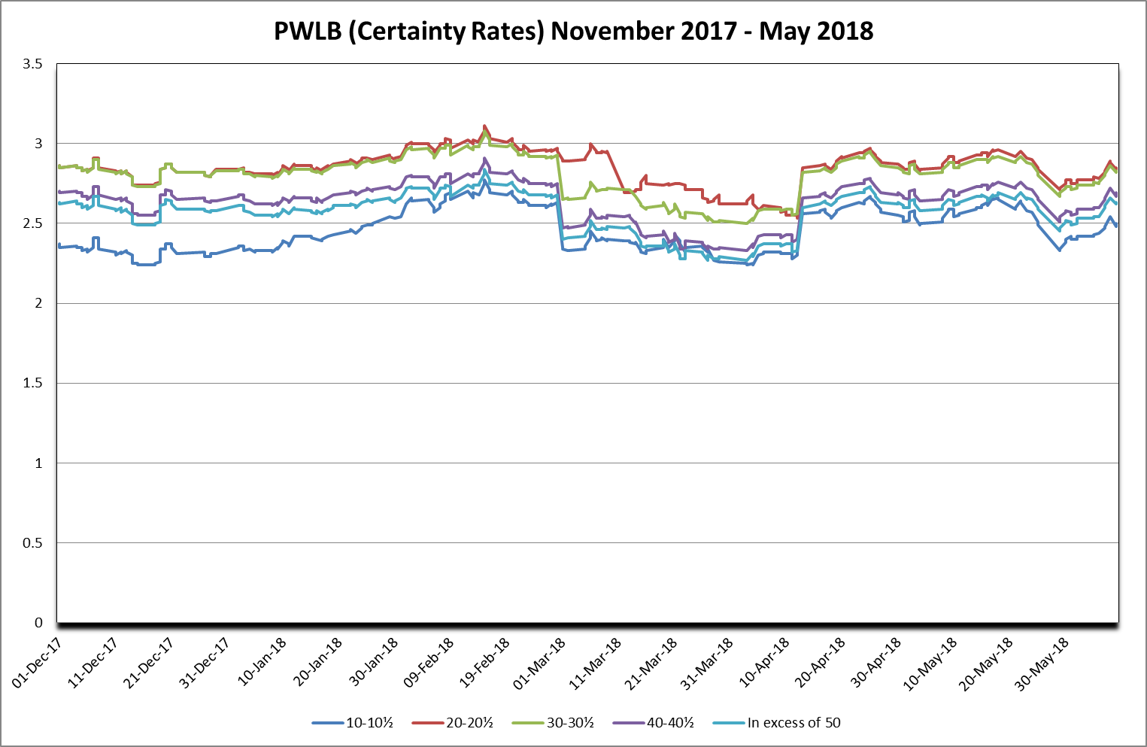

**City Council Investments**

* As at the 31st May 2018, the Council held £92.01 million of Investments
* Average investment returns in June 2016 was 0.71% for banks and building societies excluding property funds and 1.17% including property funds. Comparable current returns are 0.69% excluding property funds and 1.15% including property funds.
* The graph below shows the Council’s movement in the weighted average rate of return between April 2016 and May 2018.

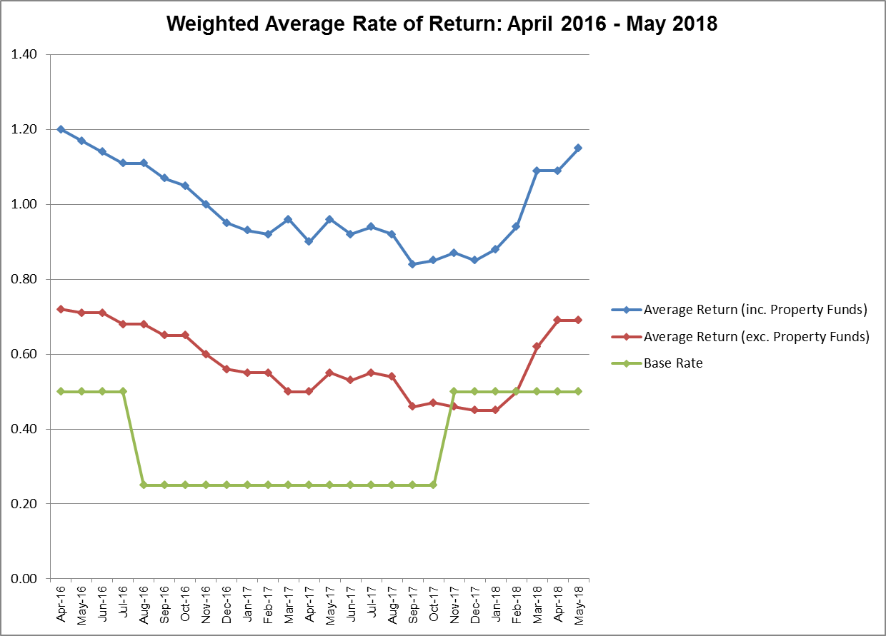

* When the Bank of England initially reduced base rate in August 2016, the effect on the Council’s investments was not immediate due to the majority of its investments being held in term deposits which were held at a fixed rate, thereby offering some form of protection to the interest levels earned.
* However, the reserve effect of this was seen in November 2017 when the Bank of England raised base rate back to 0.5%. Investments that were in place at the time of this change did not see the benefit of the rate rise until the deposits were due to mature, at which time they were reinvested at a higher rate of interest.
* The risk of rising/falling interest rates is managed by strategically planning when to invest and giving due consideration to the duration periods. However, the risk of security and liquidity are of greater concern and so the Council’s officers manage these three risks through active management and review of the Council’s investment portfolio and cashflow requirements.
* Within the draft medium term financial plan for 2019/20 an amount of £780k has been included for investment interest based on an average interest rate of 0.97% excluding property funds and 1.78% including property funds.

**Property Funds**

The Council has invested in three property funds. The primary reason for the Council investing in the CCLA and Lothbury property funds was to achieve a revenue return. Following the Brexit vote, the capital value of these funds fell, as concerns over slower economic growth and in turn demand for commercial/office property grew. As those concerns eased, both funds have not only recovered, but actually surpassed their pre-Brexit position. Both funds are still significantly above their purchase value. Investments in property funds are long term and it is expected that there will be fluctuations in the capital value throughout the period that the property fund investments are held. More detail on the property funds in which the Council holds investments are as follows:

* + **CCLA** – £3 million investment in the Local Authorities Property Fund held in two tranches. The total capital value as at the end of May 2018 was £3,847,072
  + The Council has enjoyed growth since joining the Fund although the Brexit result did have a considerable effect on the net asset value as shown on the chart below. It has fully recovered from any dips in value and the fund managers are confident the Fund will continue to grow via careful asset selection, tenant management and property improvement.
  + As at 31st May 2018, the fund size has grown to £1.026 billion
  + The Fund managers believe the portfolio of properties remains attractive with strong and robust long-term tenants, low void rates of 4.8%, no gearing and relatively low exposure to City of London and Central London properties
  + The Fund still allows redemptions

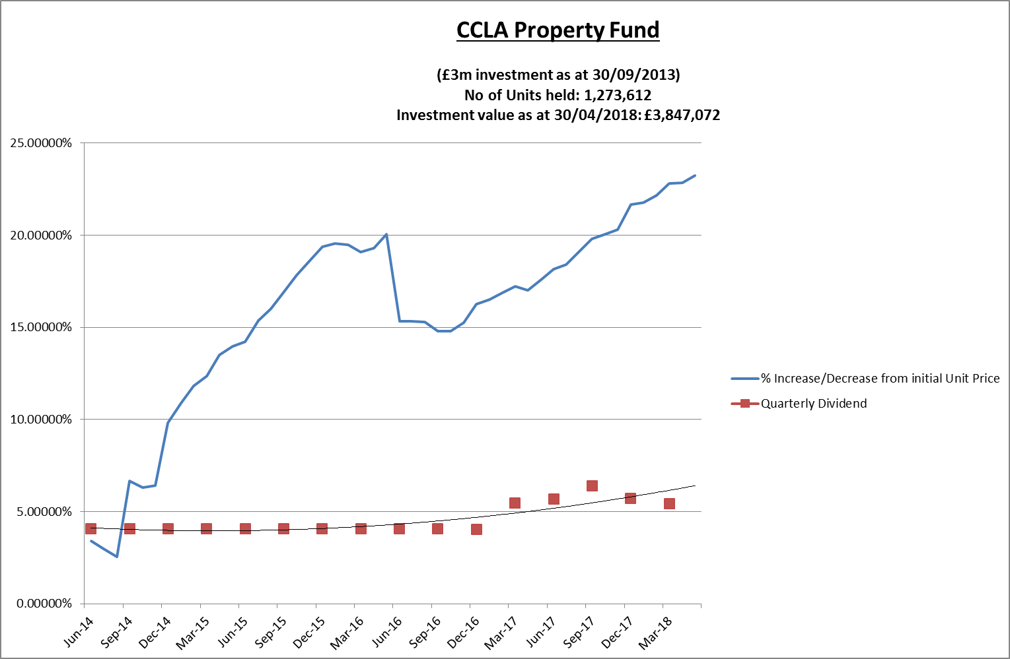

The pie chart below shows the asset allocation by type of the Fund.

* + **Lothbury** – £7 million is currently invested in the Lothbury Property Fund held in two tranches. The capital value as at the end of May 2018 was £8,398,574
  + The Council has enjoyed growth since joining the Fund and as with CCLA, it has made a full recovery after the dip in value following the Brexit referendum result. The Fund managers believe the Fund comprises investments in prime properties that are high quality, well located and secured with excellent tenants. As at 31 May 2018, the fund size was £1.718 billion
  + The Fund still allows redemptions

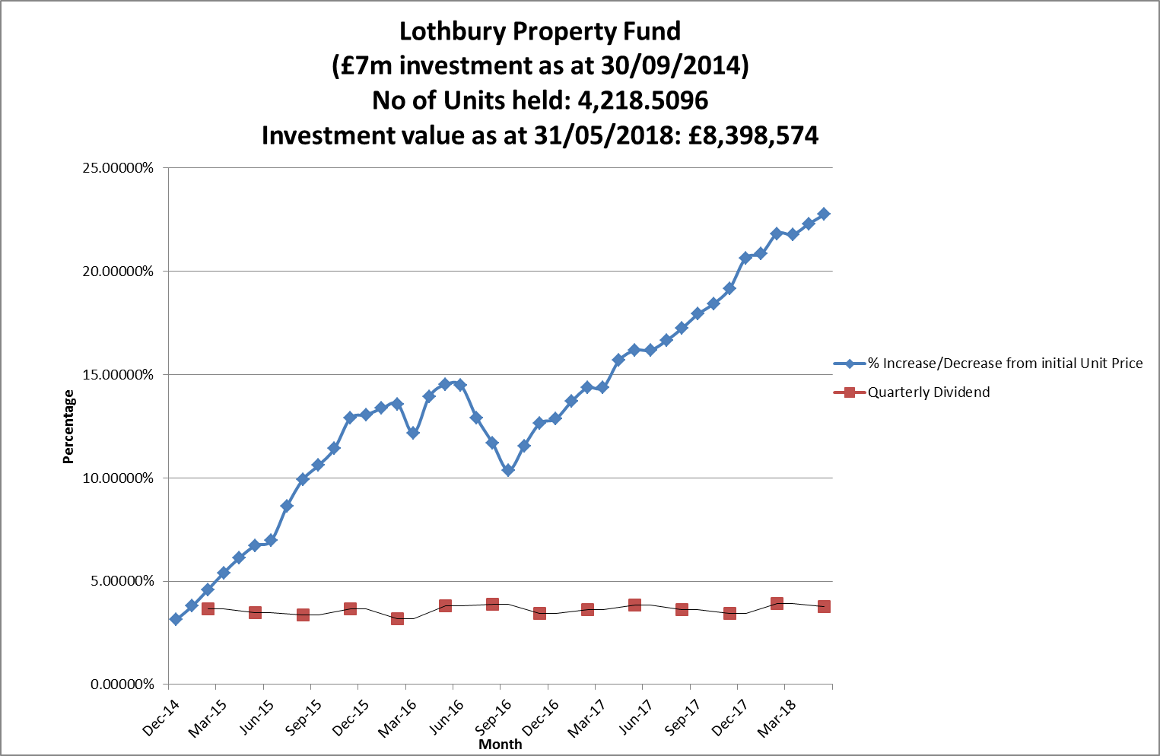

The pie chart below shows the asset allocation by type of the Fund.

**Borrowing**

Within the Council’s Medium Term Financial Plan, provision has been made for the following prudential borrowing:

|  |  |  |  |  |
| --- | --- | --- | --- | --- |
|  | **HRA** | **General Fund** | **Housing Company** | **Total** |
|  | **£000’s** | **£000’s** | **£000’s** | **£000’s** |
| 2018/19 | 532 | 10,238 | 44,965 | 55,735 |
| 2019/20 | 532 | 7,200 | 17,000 | 24,732 |
| 2020/21 | 9,835 | 450 | 12,000 | 22,285 |
| 2021/22 | 4,183 | - | 11,233 | 15,416 |
|  |  |  |  |  |
| Total | 15,082 | 17,888 | 85,198 | 118,168 |

There is currently no external borrowing on the General Fund and £198 million on the Housing Company. The HRA currently has £198million of fixed interest self-financing debt. In addition the Council currently has around £20 million of internal borrowing and reserves and balances of around £60 million which potentially provide additional headroom dependant on the Council’s expenditure profile. However, as highlighted earlier; borrowing rates are at historically low levels so officers are monitoring the situation carefully.

**Pound versus Euro**

The pound has fallen consistently against the euro since the Brexit vote to a current low of 1.11 as at July 2017. This compares to a 52 week high of 1.20 euros and a peak of 1.32 euros in May 2016 before the Brexit vote. Whilst the fall in the pound has helped exporters it has made many imported goods more expensive and foreign holidays more expensive for British tourists !

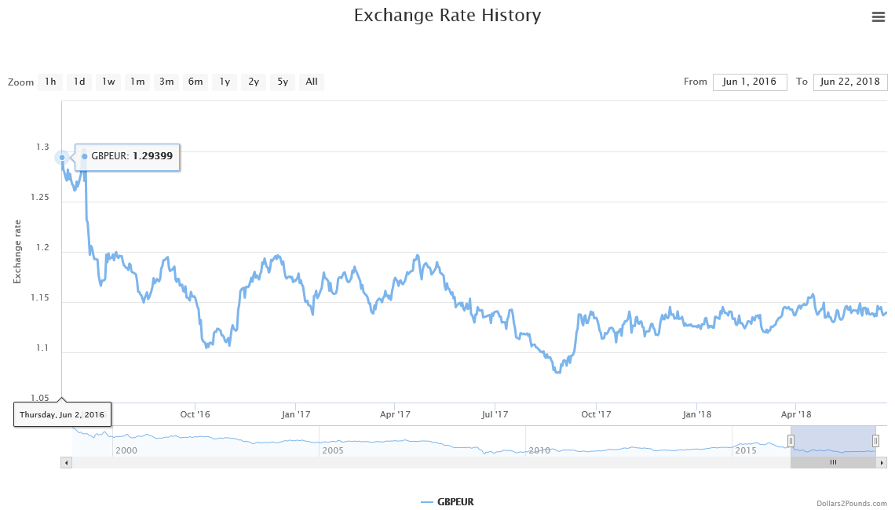

**EU Funding**

**European Structural Investment Funds (ERDF and ESF)** are historically relatively modest in Oxfordshire. Its total under this programme to 2020 is €19.3m - dwarfed by larger or less prosperous regions with a higher allocation. Nevertheless, it is a key source of niche funds for social inclusion, employability, sector based training, business support, innovation and low carbon economy. At a time of more limited national funding sources, it is difficult to imagine these being replaced with other funds at a national level. The funding is extremely valuable in filling gaps for local economic development activity, ones that cannot be funded locally, only nationally or EU wide. Oxford City Council has been able to use ESF and ERDF funds in innovative ways, for example, to leverage almost£18m of private investment in projects. Another ESF funded project helped 230 benefit claimants to find work, increase their hours, or improve their earnings, leading to a combined increase in savings and earnings of £728,000 against a fund of £198,000.

In its manifesto, the Government pledged to create a UK Shared Prosperity Fund to replace the money local areas currently receive from the European Union.

“We will use the structural fund money that comes back to the UK following Brexit to create a United Kingdom Shared Prosperity Fund, specifically designed to reduce inequalities between communities across our four nations. The money that is spent will help deliver sustainable, inclusive growth based on our modern industrial strategy. We will consult widely on the design of the fund, including with the devolved administrations, local authorities, businesses and public bodies. The UK Shared Prosperity Fund will be cheap to administer, low in bureaucracy and targeted where it is needed most

The government hasn’t provided any more details about replacement funding. However the LGA have published a briefing setting out three options for the fund which are summarised as follows:

**Option 1: No change’**. This highlights the risk of implementing a domestic regional aid policy which simply mirrors the current ESIF funding programme in terms of structure, value and allocation timescales, but does not take opportunity to innovate.

‘**Option 2: Innovative flexi-fund’** - A much welcome step forward which envisages a fundamental re-working of pre-Brexit funding arrangements to a structure that is more innovative and linked to flexible single pot allocation.

‘**Option 3: Fully integrated’** - Represents the greatest flexibility in the design of a successor arrangement for regional funding, and would include EU funding and national growth funds into one flexible fund to maximise its potential.

**EU Obligations**

There are a range of EU obligations affecting local authorities. Procurement, local economic development, waste and employment are all determined by EU regulations. It is probable that some of these regulations will remain enshrined within UK law, others may be repealed or overturned in the fullness of time.

**State Aid Rules**

Potentially some EU state aid rules would be relaxed, which could mean it is easier in some circumstances to support companies with public funding when warranted, although we would still have to comply with restrictions that may be imposed as part of a negotiated European Free Trade Agreement. The Council has applied state aid rules in the calculation of interest charged on loans made to the recently established Housing Company and similar calculations will be applied to loans to the Councils Local Authority Trading Company

**The Council’s Key Income Streams**

For an indication of what the effect of BREXIT may have on the Councils own income streams it is worth looking at what happened in the last recession and the effect on some of the Council's main income streams, i.e. car parking, planning fees, investment income, commercial property income and Business Rates. It will appreciated that past history may not be reflective of the future.

Following 6 successive quarters of negative growth the UK finally moved out of recession in the final quarter of 2009. The graph below shows the Councils’ main income streams between 2006/07 and 2017/18 which shows the trend before, during and after the recession.

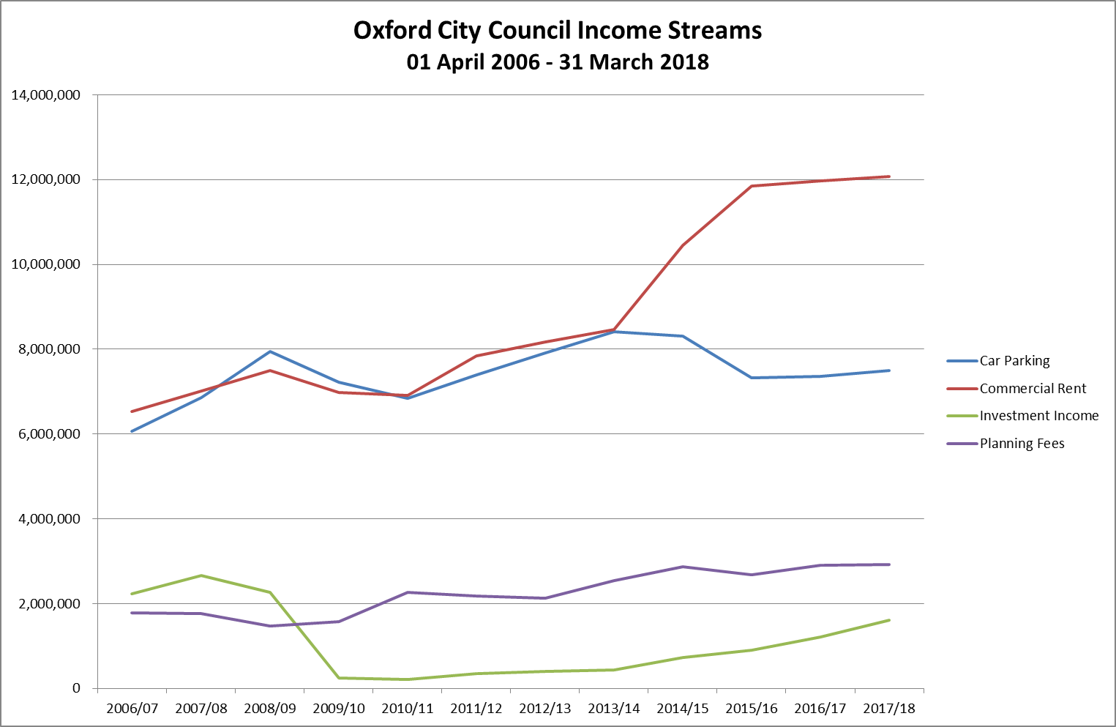

The main observations include:

* Investment income dropped significantly as base rates were cut to 0.5% and have steadily increased due a) in relation to the base rate increase and b) as a result of loans to companies
* Some dip in car parking income in 2010/11 but equally this could be explained by the transfer of 2 park and ride sites to the County Council. Car parking income in 2017-18 at year end will be in line with 2015-16 levels.
* Planning fees show some plateauing in 2008/2009 but with steady growth thereafter
* Commercial rents have continued to climb over the period, more significantly in 2014/15 which arises due to the switch of car parking income from the Westgate in favour of a fixed rental from the Westgate Development Partnership.

**Focus on Investment Property**

The Council has a commercial portfolio that currently is estimated to deliver a rental stream of around £12m in 2017/18.

**Analysis of Commercial Property Rental Income By Type of Holding**



There has been no marked change in income since the Brexit decision although the retail sector is of particular concern and the Council may need to consider diversifying its holdings.

**Labour Force**

Although the current developments on Brexit gives some assurance for EU Nationals living in the UK this has still to be agreed. In terms of the 1200 labour force in Oxford City Council only 29 are declared as EU nationals (13 in the Council and 16 in Oxford Direct Services Ltd) although there are around 85 undeclared nationality.

**Business Rates**

The business rates net collectable debit in Oxford City is shown as follows

|  |  |  |
| --- | --- | --- |
| **Business rates net collectable debit** | |  |
|  | **£000’s** | **Hereditaments** |
| 2013/14 | 85,581 | 3,895 |
| 2014/15 | 86,669 | 4,005 |
| 2015/16 | 88,488 | 3,993 |
| 2016/17 | 89,497 | 4,010 |
| 2017/18 | 95,349 | 4,286 |
| 2018/19 | 107,482 | 4,365 |

The table above shows our Business Rates income has increased significantly from October 2017 due to the opening of the new Westgate shopping centre. In the latest 2017 valuation list (dated March 31st 2018) we have 26 properties with rateable values of £1 million or over totalling £66.0 million (24.1% of total rateable value) out of a total of 4,286 properties with a total rateable value of £273.8 million.

**Highest rating assessments**

|  |  |
| --- | --- |
| **Rating Assements 2018-19 RV** | |
|  | **£000’s** |
| Oxford University Science Area | 12,560 |
| BMW Motor Vehicle Works | 7,940 |
| John Radcliffe Hospital | 6,130 |
| Oxford University – Old Road Campus | 3,960 |
| Oxford Brookes University | 3,700 |
| Unipart Limited | 2,610 |
| Sainsburys Superstore | 2,600 |
| Virgin Media, Shelley Court | 2,240 |
| Others with RV of £1m or more | 24,250 |
| Total | 65,990 |